**Note:** If you are trying to access SAS virtually **outside campus**, then follows steps **1)** and **2)** or else if trying to access SAS virtually on-campus directly go to step **2).**

1. **Pre-Requisite to connect to VDI Desktops outside OSU**

We need to be on college network to access SAS using VMware. So we can use VPN to be on college network virtually and then access VMware.

1. Go to <https://osuvpn.okstate.edu>
2. Log in using your O-Key credentials.
3. Once you have successfully authenticated, follow the on-screen instructions to install the OSU VPN application.

Click on “Install ActiveX” if prompted and click on “Run” for Java prompt.

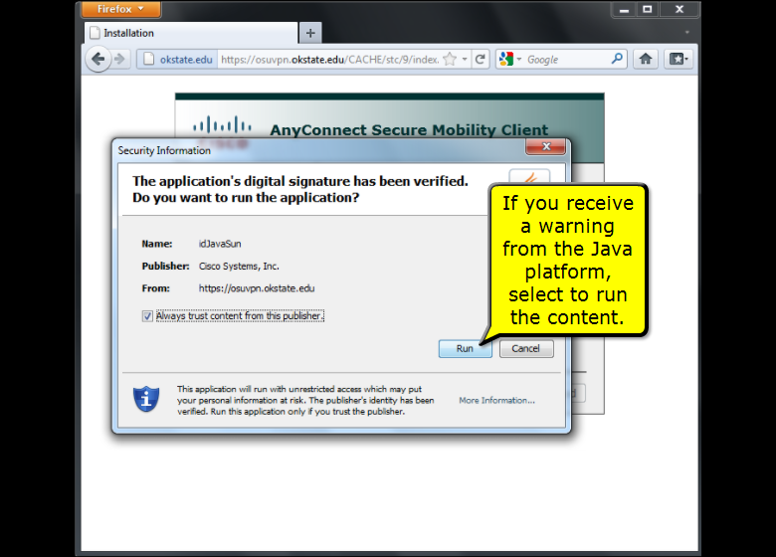

1. If automatic installation fails, click on “Download” to manually download and install “Cisco AnyConnect VPN Utility”
2. After installation is complete, it will automatically connect to the osuvpn or else in VPN type: **osuvpn.okstate.edu**

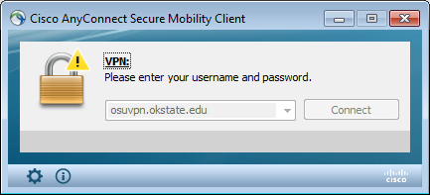

1. Click on connect and enter your login details if prompted.

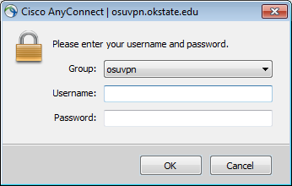

1. The connection has been established and you should then be able to connect to OSU Network Resources.

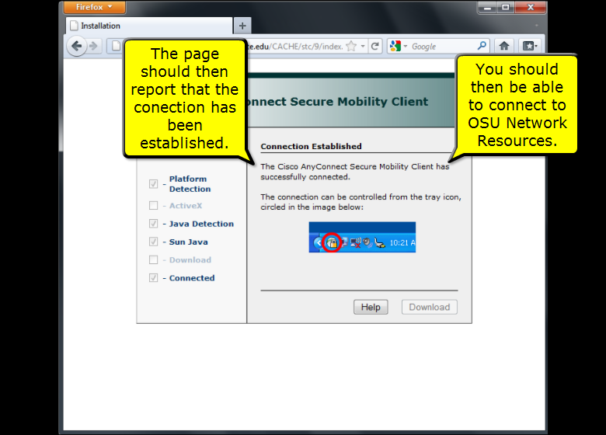

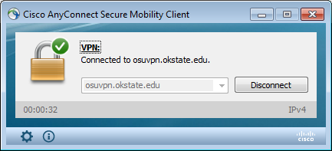

1. You may connect to desktop.okstate.edu using VMware (Instructions given below).
2. After your work is done, open Cisco VPN minimized in taskbar and disconnect the service.
3. The Cisco VPN utility is installed on your machine and for next time you can directly open the application in your system.

* Microsoft Windows XP or higher
* From the Start menu, search: Cisco AnyConnect Mobility Client or else Locate and open the Cisco folder in program files.
* Open the Cisco AnyConnect Mobility Client
* Execute the Cisco AnyConnect Mobility Client application.
* The Cisco VPN client should appear, ensure that the drop-down box is set to osuvpn.okstate.edu and then click the Connect button.
* When you are asked to authenticate, use your O-Key credentials.
* Apple Mac OS X 10.5.X or higher
* From the Finder, open the Go menu.
* Select the Applications option.
* A new window titled Applications should appear, Locate and open the Cisco folder.
* Execute the Cisco AnyConnect Mobility Client application.
* When the application loads, ensure that osuvpn.okstate.edu is selected and click the Connect button.
* When asked to authenticate, enter your O-Key credentials.

1. **Connecting to VDI Desktops**
2. Go to <https://desktop.okstate.edu>
3. Click on the “Install VMware Horizon Client” icon. The required software for your computer will begin downloading.

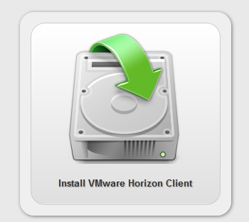

1. Run the installation file and accept the default installation options.
2. During setup you will be prompted to enter in the “Default Horizon Connection Server.” Enter in desktop.okstate.edu.

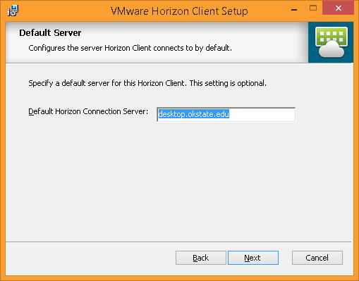

1. Once the installation completes, you may be prompted to restart your computer. Please do so if asked.
2. Run the VMware Horizon Client program. To connect, double click the “desktop.okstate.edu” icon.
3. You will login using your OKEY account credentials.

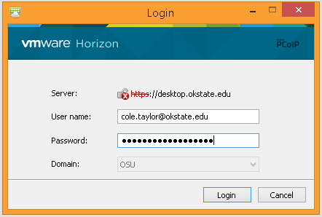

1. You will then be presented with the desktop(s) you have access to. Double click a desktop to launch it.
2. **THIS WILL ONLY WORK ON UNVERISTY NETWORK**, so connect using VPN if accessing from outside OSU network.